AI Scam Detector

Problem Statement
Today with growth of AI Online scams through SMS, email, phishing links, and WhatsApp messages are increasing rapidly. Users often fail to identify fraudulent messages because scammers use social engineering tactics such as urgency, fake rewards, OTP requests, and account threats. This project (AI Scam Detector) aims to automatically detect scam messages using Artificial Intelligence and give the seriousness of the issue.

Proposed Solution
So The system uses Machine Learning and Large Language Model (LLM) analysis to classify messages as Scam or Legitimate. The backend first attempts intelligent analysis using GroqCloud APIs. If the API fails, the application falls back to a locally trained Machine Learning model with TF-IDF Vectorization and logistic regression.

3. Project Explanation
The AI Scam Detector provides a practical cybersecurity solution for detecting fraudulent messages. The combination of Machine Learning and LLM technologies improves scam detection accuracy and user awareness. The project contains a frontend built using HTML, CSS, and JavaScript, and a backend built using Flask. Users paste suspicious messages into the interface. The backend processes the message, detects suspicious phrases, checks URLs, analyzes fraud patterns, and returns a scam score with explanations. Its main features are :
- Scam detection
- Risk score generation
- URL analysis
- Fraud pattern analysis
- Suspicious keyword detection
- AI-generated explanations
- ML fallback support
Once if the network is not stable or the api limit rate has reached and the model failed to run. We locally trained a Machine Learning model with 6000+ data using TF-IDF Vectorization and Logistic Regression With Accuracy 96%.
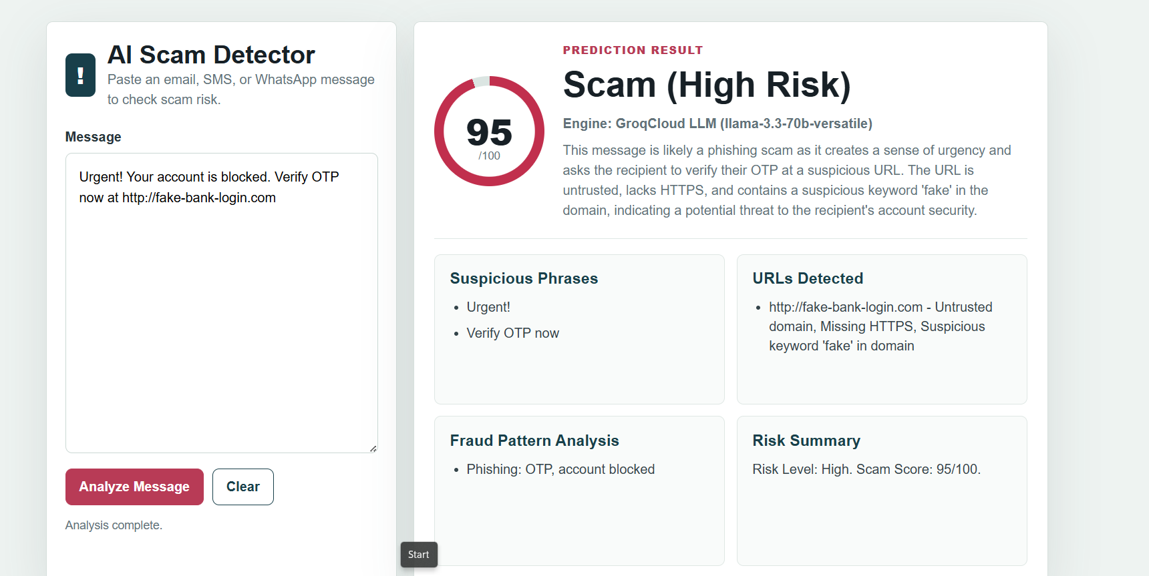

Technologies Used
- HTML
- CSS
- JavaScript
- Python Flask
- Scikit-learn
- Joblib
- GroqCloud API
- Logistic Regression
- TF-IDF Vectorization
Dataset Used To Train The Model:
In kaggle Download “The Enron Email dataset” and “Spam Mails” dataset.
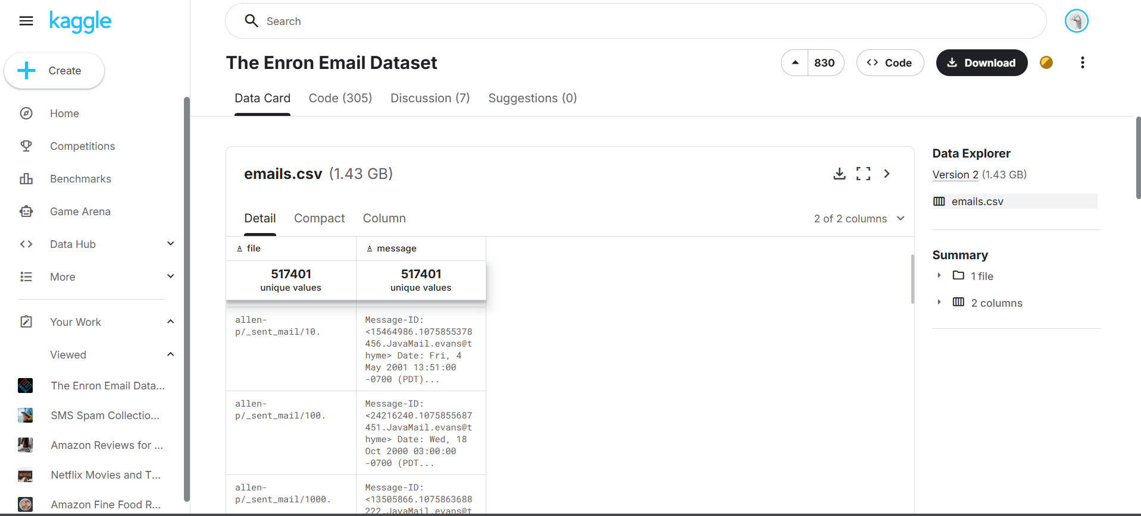
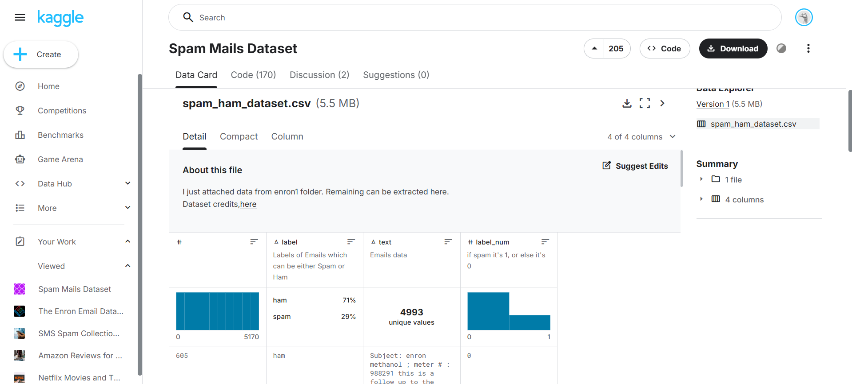

Model Training
The ML model was trained using spam and email datasets. Over more than 6000+ data’s it has been trained. TF-IDF vectorization converts text into numerical form, and Logistic Regression performs classification. The trained model achieved approximately 98.6% accuracy. And confusion matrix False negative found to be 11 and False Positives Found to be 17 as optimized to maximum . We achieved this wit class balance between legit and scam.

Performance Evaluation:
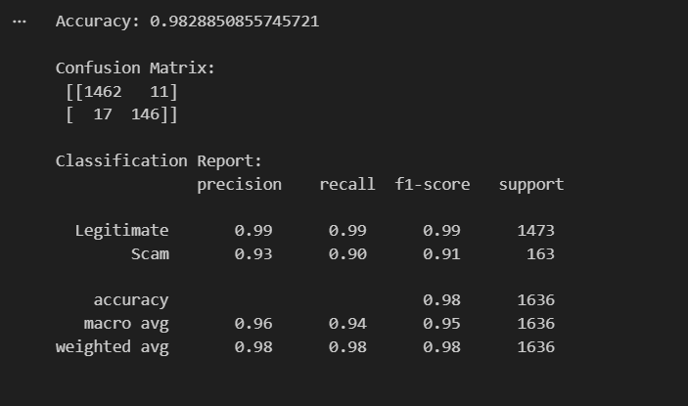

Limitations Of The Project :
- Detection accuracy depends on training data.
- New scam patterns may bypass detection.
- Internet is required for LLM-based analysis.
- The system mainly supports English text.
- Image and voice scam detection are not implemented.

Future Enhancements :
- Add multilingual support
- Add image and voice scam analysis
- Develop mobile application support
- Deploy the system to cloud platforms
- Improve real-time phishing detection
- Add continuous learning using user feedback

